

Dr. Jeremy, Singh inc.

2020-06-22

Dr. Singh

193 Gutierrez Stream, Wrighttown, NC 14657

Phone: 4170038610

Fax: 5869811173

**Re:** Sandra, Jones

**PHN:** 627310953

**Birthdate:** 06-Nov-1961

**Address:** 2820 Kevin Cliffs Suite 242, New Johnburgh, NY 73820

**Patient number:** 4647489583

To Whom It May Concern:

This is a medical letter to state the above patient is pregnant with expected delivery date of 27-Aug-2025. Hoping this information is satisfactory for your requirements.

Thank you.

Sincerely,

Dr. Jeremy, Singh

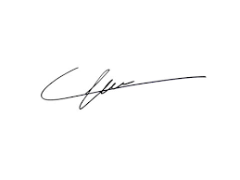

FRCS© NCMP

Clinical Assistant Professor, UBC

Department of Obstetrics and Gynecology SMH